American Airlines expands its playbook with added flights and exclusive access to tickets for all FIFA World Cup 26 matches

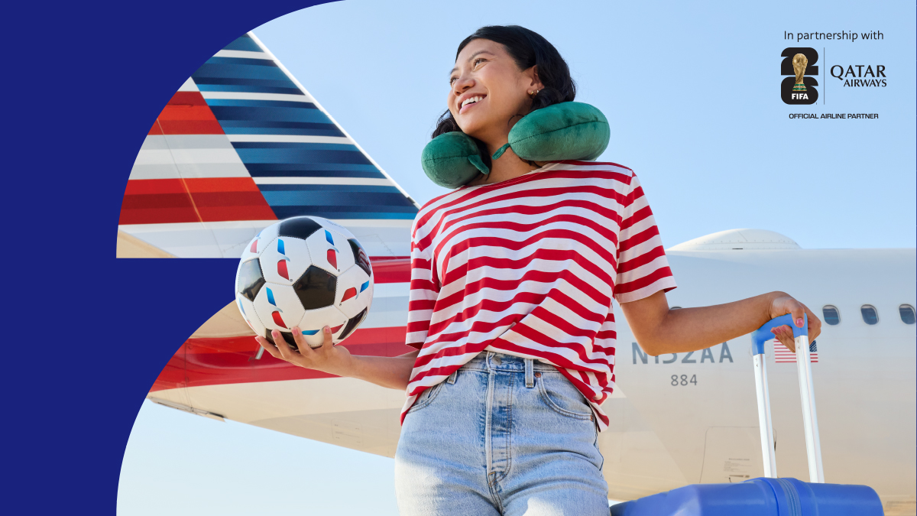

FORT WORTH, Texas — American Airlines is giving customers the perfect assist ahead of FIFA World Cup 26™. The airline is making it easier than ever to get to every match with additional flight options, more opportunities to redeem AAdvantage® miles for tickets and exclusive Perks that AAdvantage® members can only get through American. In addition, to celebrate the airline’s sponsorship as the Official North American Airline Supplier of FIFA World Cup 26™, American will roll out aircraft decal installations on its domestic fleet and launch a creative marketing campaign leading up to the FIFA World Cup 26™ Final Draw in Washington, D.C. on Dec. 5.

From takeoff to kickoff, getting fans to every match
As soon as soccer fans know where and when their favorite teams will take the pitch, American will have additional flights ready for sale to get them to every match. The airline is adding frequencies and flying larger planes between the 16 host cities across the United States, Canada and Mexico, making it easy for fans to follow their teams from the group stage to the final match.

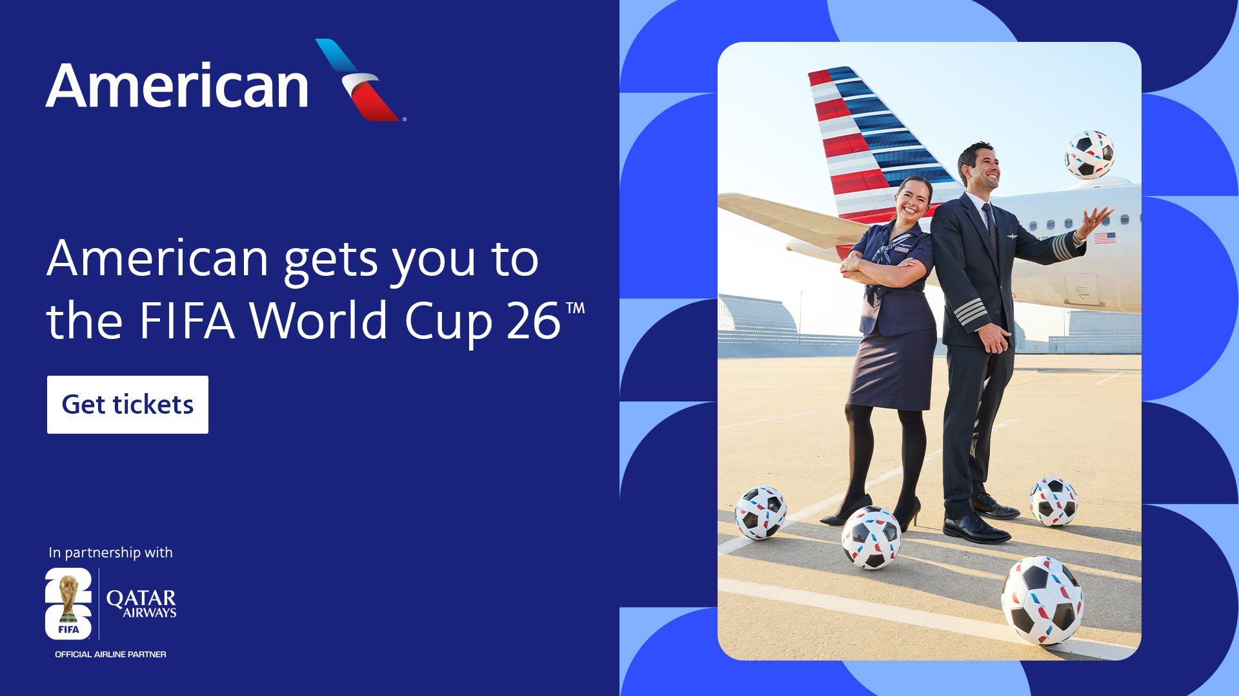American Airlines debuts “Now Boarding: Super Fans” digital-only campaign

“American is ready with its game plan for the FIFA World Cup 26™, adding an extra 27,000 seats on 12 routes this summer,” said Brian Znotins, American’s Senior Vice President of Network Planning. “With more flights to all host cities, we’re making sure fans don’t miss the chance to take part in this once-in-a-lifetime moment across North America. “

Along with more flights between Los Angeles and Seattle or Boston and Dallas-Fort Worth, American is introducing nonstop service between Atlanta and Kansas City during the quarterfinal round.

Market | Dates | Additional flying
Boston (BOS)-Dallas Fort Worth (DFW) | June 18-July 11 | More flights and upgauged aircraft
Atlanta (ATL)-Miami (MIA) | June 16-July 17 | More flights and upgauged aircraft
Philadelphia (PHL)-Toronto (YYZ) | June 15-June 30 | Upgauged aircraft
Kansas City (MCI)-PHL | June 15-June 22 | Upgauged aircraft
Los Angeles (LAX)-Seattle (SEA) | June 13-July 8 | Upgauged aircraft
ATL-New York LaGuardia (LGA) | July 16-July 17 | More flights and upgauged aircraft
LAX-Vancouver (YVR) | June 16-June 26 | More flights
DFW-San Jose, California (SJC) | June 17-June 27 | More flights
ATL-PHL | June 20-June 21 | More flights and upgauged aircraft
LGA-MCI | June 21-June 22 | New nonstop flights
MIA-YYZ | June 28-June 29 | Upgauged aircraft
ATL-MCI | July 8-July 13 | New nonstop flights

Flights are available to purchase now at aa.com/en-us/fwc26 or through American’s mobile app.

Don’t miss a single goal with exclusive access to redeem miles for match tickets
As millions of fans prepare for the world’s biggest sporting event, American is giving AAdvantage® members another unique way to join in on the action by redeeming AAdvantage® miles for FIFA World Cup 26™ match tickets. AAdvantage® members will have early access to redeem miles for all match tickets through American based on their status level.

Here’s the game plan
- Dec. 17 — AAdvantage Executive Platinum® status and ConciergeKey® members
- Dec. 18 — AAdvantage Gold® status, AAdvantage Platinum® status and AAdvantage Platinum Pro® status members
- Dec. 19 — All AAdvantage® members

To stay ahead of the game, members are encouraged to download the American app and enable push notifications for ticket access alerts starting Dec. 17, based on member status level. Visit the website to learn more.

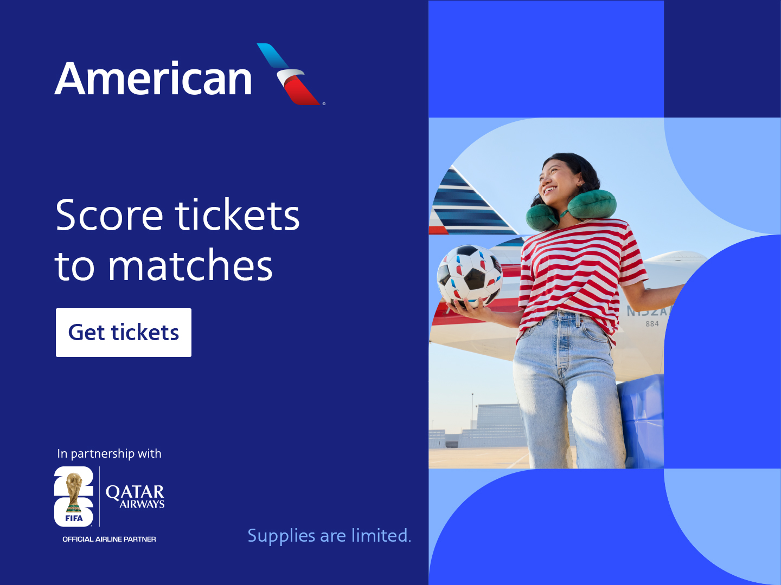
American Airlines debuts “Now Boarding: Super Fans” digital-only campaign

More ways to earn AAdvantage® miles
Members can earn miles and Loyalty Points by flying or engaging with the airline’s partners, getting them closer to status for exclusive access to FIFA World Cup 26™ match tickets. AAdvantage® members can also save up to 40% when buying AAdvantage® miles. Not an AAdvantage® member? Joining is easy and free by visiting American’s website.

“After a successful first round of ticket redemptions, we’re thrilled to give AAdvantage® members even more chances to be part of the action” said Scott Long, American’s Senior Vice President of AAdvantage®. “From the opening to the final match, we’re committed to delivering exclusive experiences for our most loyal members and making it easier for them to follow their teams all the way through FIFA World Cup 26™.”

Score exclusive experiences through FIFA World Cup 26™ Perks
American goes the extra mile in rewarding sports enthusiasts with exciting opportunities to experience their favorite teams. To reward their love of travel and sports, American is giving AAdvantage® members daily opportunities to enter sweepstakes throughout the year for a chance to win exciting prizes that gets fans closer to the action.

Beginning Dec. 6, fans may visit www.fwc26perks.com/ for a chance to win any one of the following AAdvantage® Perks — available only to members of American’s AAdvantage® loyalty program, which offers countless ways for customers to earn and redeem miles:
- Opening match tickets to FIFA World Cup 26™ (currently available on Perks)
- Group stage match of choice
- Watch a U.S. Men’s National Team group stage match
- Watch a FIFA World Cup 26™ match with a FIFA Legend

American celebrates FIFA World Cup 26™ with custom decals across domestic fleet and national creative campaign
As the Official North American Airline Supplier of FIFA World Cup 26™, American is taking its sponsorship to new heights. Starting this month, every aircraft in the American Airlines fleet — totaling more than 1,550 aircraft — will proudly display a custom FIFA World Cup 26™ decal, in partnership with Qatar Airways, honoring the airlines commitment to connecting fans, teams and the world’s most celebrated sporting event. The decals will be applied across the domestic fleet by the end of December, allowing travelers to share in the excitement as American counts down to kickoff.

Also, this month, fans will begin seeing American’s new creative content celebrating the upcoming FIFA World Cup 26™ across national television, digital and social platforms. Along with a “Now Boarding: Super Fans” digital-only campaign, American will launch a 0:30 broadcast spot, “Fandom Takes Flight.”

Fandom takes flight — 30 - YouTube

American Airlines launches broadcast spot, "Fandom Takes Flight”


American Airlines debuts “Now Boarding: Super Fans” digital-only campaign

About American Airlines Group
As a leading global airline, American Airlines offers thousands of flights per day to more than 350 destinations in more than 60 countries. The airline is a founding member of the oneworld alliance, whose members serve more than 900 destinations around the globe. Shares of American Airlines Group Inc. trade on Nasdaq under the ticker symbol AAL. Learn more about what’s happening at American by visiting news.aa.com and connect with American @AmericanAir and at Facebook.com/AmericanAirlines. To Care for People on Life’s Journey®.

